# Lab 9 – Images in MATLAB

## Exercise

### Exercise 1

Apply filter to the salt & pepper image using MATLAB Commands.

**Code:**

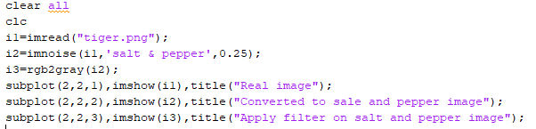

**Output:**

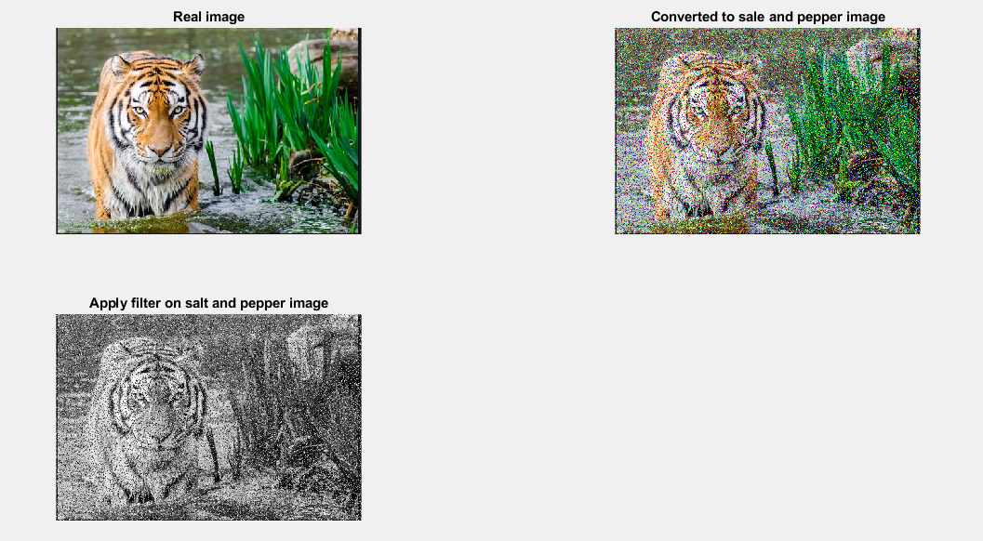

### Exercise 2

Add Gaussian noise on grayscale image using MATLAB Commands.

**Code:**

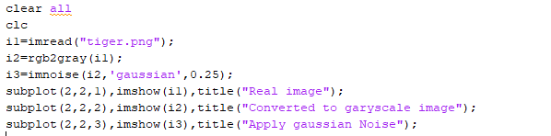

**Output:**

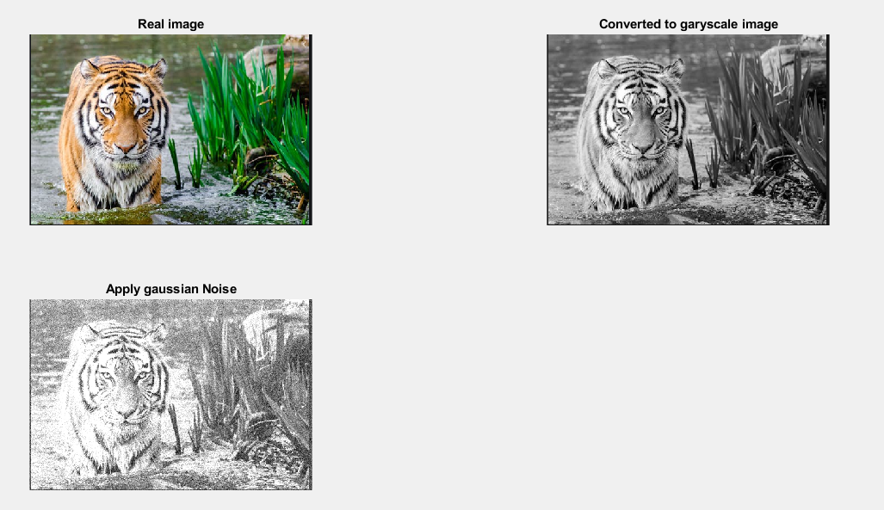

### Exercise 3

Apply filter to the Gaussian image using MATLAB Commands.

**Code:**

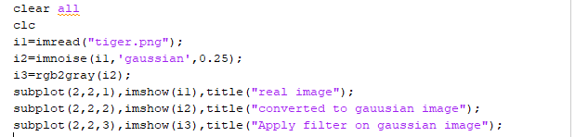

**Output:**

